What is The Waterfall Model?
Waterfall Model is a sequential model that divides software development into pre-defined phases. Each phase must be completed before the next phase can begin with no overlap between the phases. Each phase is designed for performing specific activity during the SDLC phase. It was introduced in 1970 by Winston Royce.
Different Phases of Waterfall Model in Software Engineering
1-Requirement Gathering stage
During this phase, detailed requirements of the software system to be developed are gathered from client
2-Design Stage
Plan the programming language, for Example Java, PHP, .net
or database like Oracle, MySQL, etc.
Or other high-level technical details of the project
3-Built Stage
After design stage, it is built stage, that is nothing but coding the software
4-Test Stage
in this phase, you test the software to verify that it is built as per the specifications given by the client.
5-Deployment stage
Deploy the application in the respective environment
6-Maintenance stage
Once your system is ready to use, you may later require change the code as per customer request
When to use SDLC Waterfall Model?
Requirements are not changing frequently
Application is not complicated and big
Project is short
Requirement is clear
Environment is stable
Technology and tools used are not dynamic and is stable
Resources are available and trained

Advantages Waterfall Model
Before the next phase of development, each phase must be completed
Suited for smaller projects where requirements are well defined
They should perform quality assurance test (Verification and Validation) before completing each stage
Elaborate documentation is done at every phase of the software’s development cycle
Project is completely dependent on project team with minimum client intervention
Any changes in software is made during the process of the development

DisAdvantages Waterfall Model
Error can be fixed only during the phase
It is not desirable for complex project where requirement changes frequently
Testing period comes quite late in the developmental process
Documentation occupies a lot of time of developers and testers
Clients valuable feedback cannot be included with ongoing development phase
Small changes or errors that arise in the completed software may cause a lot of problems

V Model
V Model is a highly disciplined SDLC model which has a testing phase parallel to each development phase. The V model is an extension of the waterfall model where in software development and testing is executed in a sequential way. It is known as the Validation or Verification Model.

Phases of Software Development
1-Requirement Gathering stage
Gather as much information as possible about the details & specifications of the desired software from the client. This is nothing but the Requirements gathering stage.
2- Design Stage
Plan the programming language like Java, PHP, .net; database like Oracle, MySQL, etc. Which would be suited for the project, also some high-level functions & architecture.
3-Build Stage
After the design stage, it is build stage, that is nothing but actually code the software
4-Test Stage
Next, you test the software to verify that it is built as per the specifications are given by the client.
5-Deployment stage
Deploy the application in the respective environment
6-Maintenance stage
Once your system is ready to use, you may require to change the code later on as per customer request
Problem with the Waterfall Model
As you may observe, that testing in the model starts only after implementation is done.
But if you are working in the large project, where the systems are complex, it’s easy to miss out the key details in the requirements phase itself. In such cases, an entirely wrong product will be delivered to the client and you might have to start afresh with the project OR if you manage to note the requirements correctly but make serious mistakes in design and architecture of your software you will have to redesign the entire software to correct the error.

Solution: The V Model
To address this concern, the V model of testing was developed where for every phase, in the Development life cycle there is a corresponding Testing phase
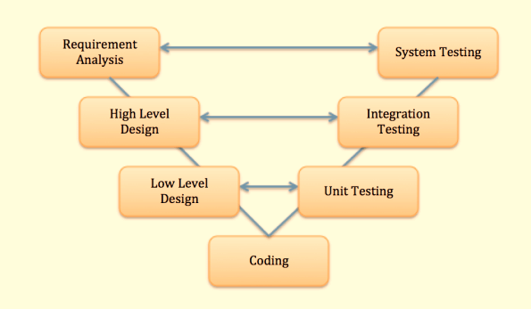
The left side of the model is Software Development Life Cycle – SDLC
The right side of the model is Software Test Life Cycle – STLC
The entire figure looks like a V, hence the name V – model
Apart from the V model, there are iterative development models, where development is carried in phases, with each phase adding a functionality to the software. Each phase comprises its independent set of development and testing activities.
Conclusion
There are numerous development life cycle models. Development model selected for a project depends on the aims and goals of that project.
Testing is not a stand-alone activity, and it has to adapt the development model chosen for the project.
In any model, testing should be performed at all levels i.e. right from requirements until maintenance.
V-Model Pros & Cons
Pros of V-Model
This is a highly disciplined model and Phases are completed one at a time.
Works well for smaller projects where requirements are very well understood.
Simple and easy to understand and use.
Easy to manage due to the rigidity of the model. Each phase has specific
deliverables and a review process.

product - deliever -

Cons of V-Model
High risk and uncertainty.
Not a good model for complex and object-oriented projects.
programing
1 loselly coupel
2 tightly couple

Poor model for long and ongoing projects.
Not suitable for the projects where requirements are at a moderate to high risk of changing.
Once an application is in the testing stage, it is difficult to go back and change a
functionality
No working software is produced until late during the life cycle.

Iterative Model
you can start with some of the software specifications and develop the first version of the software. After the first version if there is a need to change the software, then a new version of the software is created with a new iteration. Every release of the Iterative Model finishes in an exact and fixed period that is called iteration.
The Iterative Model allows the accessing earlier phases, in which the variations made respectively. The final output of the project renewed at the end of the Software Development Life Cycle (SDLC) process
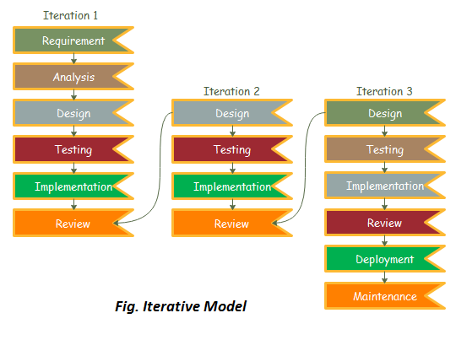
The various phases of Iterative model are as follows:
1. Requirement gathering & analysis: In this phase, requirements are gathered from customers and check by an analyst whether requirements will fulfil or not. Analyst checks that need will achieve within budget or not. After all of this, the software team skips to the next phase.

2. Design: In the design phase, team design the software by the different diagrams like Data Flow diagram, activity diagram, class diagram, state transition diagram, etc.
3. Implementation: In the implementation, requirements are written in the coding language and transformed into computer programmes which are called Software.

4. Testing: After completing the coding phase, software testing starts using different test methods. There are many test methods, but the most common are white box, black box, and grey box test methods.

5. Deployment: After completing all the phases, software is deployed to its work environment.

6. Review: In this phase, after the product deployment, review phase is performed to check the behaviour and validity of the developed product. And if there are any error found then the process starts again from the requirement gathering.

7. Maintenance: In the maintenance phase, after deployment of the software in the working environment there may be some bugs, some errors or new updates are required. Maintenance involves debugging and new addition options.
When to use the Iterative Model?
When requirements are defined clearly and easy to understand.
When the software application is large.
When there is a requirement of changes in future.
Advantage(Pros) of Iterative Model:
Testing and debugging during smaller iteration is easy.
A Parallel development can plan.
It is easily acceptable to ever-changing needs of the project.
Risks are identified and resolved during iteration.
Limited time spent on documentation and extra time on designing.
Disadvantage(Cons) of Iterative Model:
It is not suitable for smaller projects.
More Resources may be required.
Design can be changed again and again because of imperfect requirements.
Requirement changes can cause over budget.
Project completion date not confirmed because of changing requirements.

What is Bohem’s Spiral Model?
Spiral Model is a risk-driven software development process model. It is a combination of waterfall model and iterative model. Spiral Model helps to adopt software development elements of multiple process models for the software project based on unique risk patterns ensuring efficient development process.

Each phase of spiral model in software engineering begins with a design goal and ends with the client reviewing the progress. The spiral model in software engineering was first mentioned by Barry Boehm in his 1986 paper.

The development process in Spiral model in SDLC, starts with a small set of requirement and goes through each development phase for those set of requirements. The software engineering team adds functionality for the additional requirement in every-increasing spirals until the application is ready for the production phase.

Spiral Model Phases
Planning - It includes estimating the cost, schedule and resources for the iteration. It also involves understanding the system requirements for continuous communication between the system analyst and the customer
Risk Analysis - dentification of potential risk is done while risk mitigation strategy is planned and finalized
Engineering - It includes testing, coding and deploying software at the customer site
Evaluation - Evaluation of software by the customer. Also, includes identifying and monitoring risks such as schedule slippage and cost overrun

When to use Spiral Model?
A Spiral model in software engineering is used when project is large
When releases are required to be frequent, spiral methodology is used
When creation of a prototype is applicable
When risk and costs evaluation is important
Spiral methodology is useful for medium to high-risk projects
When requirements are unclear and complex, Spiral model in SDLC is useful
When changes may require at any time
When long term project commitment is not feasible due to changes in economic priorities

Spiral Model Advantages
Additional functionality or changes can be done at a later stage
Cost estimation becomes easy as the prototype building is done in small fragments
Continuous or repeated development helps in risk management
Development is fast and features are added in a systematic way in Spiral development
There is always a space for customer feedback

Spiral Model DisAdvantages
Risk of not meeting the schedule or budget
Spiral development works best for large projects only also demands risk assessment expertise
For its smooth operation spiral model protocol needs to be followed strictly
Documentation is more as it has intermediate phases
Spiral software development is not advisable for smaller project, it might cost them a lot

Scrum
SCRUM is an agile development method which concentrates specifically on how to manage tasks within a team-based development environment. Basically, Scrum is derived from activity that occurs during a rugby match. Scrum believes in empowering the development team and advocates working in small teams (say- 7 to 9 members). Agile and Scrum consist of three roles, and their responsibilities are explained as follows:
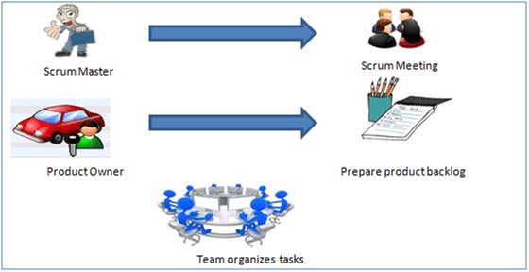

Scrum Master
Scrum Master is responsible for setting up the team, sprint meeting and removes obstacles to progress
Product owner
The Product Owner creates product backlog, prioritizes the backlog and is responsible for the delivery of the functionality at each iteration
Scrum Team
Team manages its own work and organizes the work to complete the sprint or cycle
Product Backlog
This is a repository where requirements are tracked with details on the no of requirements(user stories) to be completed for each release. It should be maintained and prioritized by Product Owner, and it should be distributed to the scrum team. Team can also request for a new requirement addition or modification or deletion

Scrum Practices
Practices are described in detailed:
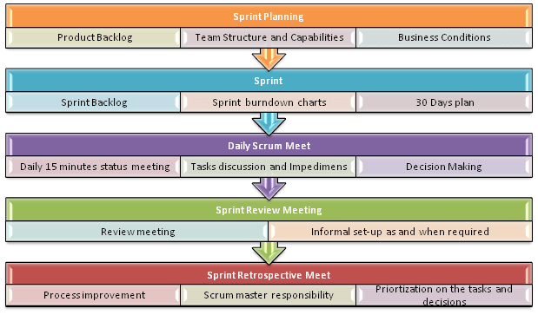
Process flow of Scrum Methodologies:
Process flow of scrum testing is as follows:

Each iteration of a scrum is known as Sprint
Product backlog is a list where all details are entered to get the end-product
During each Sprint, top user stories of Product backlog are selected and turned into Sprint backlog
Team works on the defined sprint backlog
Team checks for the daily work
At the end of the sprint, team delivers product functionality

